The AB Hancer
Student’s Name
Institutional Affiliation

The AB Hancer
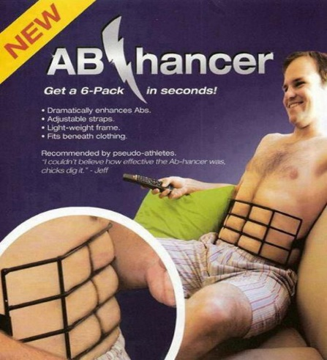
The modern market is flooded with strange products that seem ingenious and also funny. From the Strange New Products website, I picked the AB Hancer as my favorite, weird and stupidest product on the market. The manufacturer of the product took advantage of the higher demand by people especially men to have a chiseled stomach in the name of six packs. The manufacturer discovered that despite the high desire for abs muscles, men were not willing to work for them in the gym. This is partially attributed time and also the physical pain and endurance that one has to face for months and even years to develop abs. The AB Hancer steps in to give a false six-pack presentation in minutes (Ridiculous Products, 2021). The tool is light in weight and easy to hide under clothing. It is a metal bar tool with straps that can be adjusted around the back as desired by the user.
The AB Hancer is used by wrapping around the mid -section of the back. The metal bar has a representation of abdominal abs that the user needs to strategically place against the expected abs positions on his stomach. For the user to gain the temporary abs, he needs to wrap up around his back and leave it in the same position for a desirable time to get maximum results. The tool makes marks of abs that protrude from the clothing just like the traditional work-out abs.
I believe the product does not fill an unmet need. My reason lies in the fact that the tool gives a temporary impression that lasts for few minutes and disappears. The traces of abs created by the AB Hancer do not last.
I can rate it at 4 (unlikely to succeed) because the false impression does not last. Also, they are likely to cause embarrassment in situations where people need to be nude or half-nude.

Reference
Ridiculous Products (2021). Funny and Strange Things You Can Actually Buy. Retrieved from https://removeandreplace.com/2013/05/28/ridiculous-products-stupid-strange-funny-and-weird-things-you-can-actually-buy/

